Jack Weinmann Implementation of a Simplified TCP-like Nov. 21, 2019
Daylend de Grasse Protocol for Server-to-Client Data Transfer CPSC 3780
Using a Go-Back-n Configuration

Teams

Jack and Daylend are individual members of two different teams. Jack will be implementing the server, and Daylend will be implementing the client. We will both be implementing the proxy. We are both separate teams and therefore are each focusing on our own part of the project (Server or Client), however we will maintain communication throughout the implementation to ensure the server and client will communicate effectively.

Progress

The majority of our progress so far has been in designing the header. We’ve discussed in detail what header segments would be needed as well as what sizes each segment should be. That said, we know that we should be prepared for changes, whether that’s adding, removing, or adjusting the sizes of the segments, and are therefore being careful to write code that can easily be changed. We’ve also done the same regarding the connection establishment and termination. The establishment will use a 3-way handshake, and the termination a 2-way handshake.

Thus far, both Jack and Daylend have mostly written code for interpretting and manipulating headers directly from a bytearray and bytes-type variables. They provide methods to easily build the header and packet, but the logic that will make use of them has not yet been written.

Jack, who is developing the server, has also written some code for reading files into bytearrays so that precisely-sized “chunks” of data can be easily provided to the logic that will construct the packets.

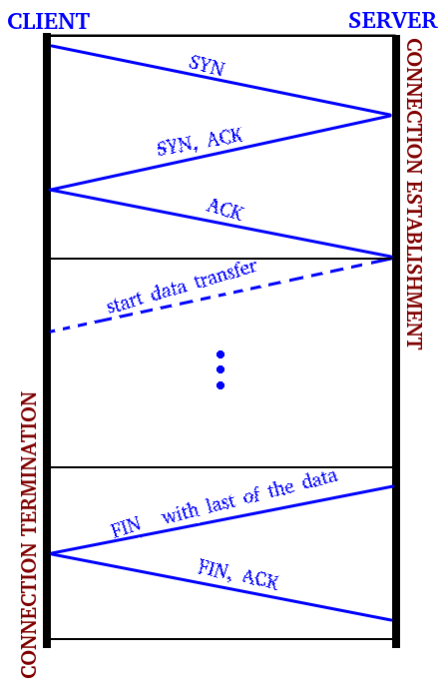
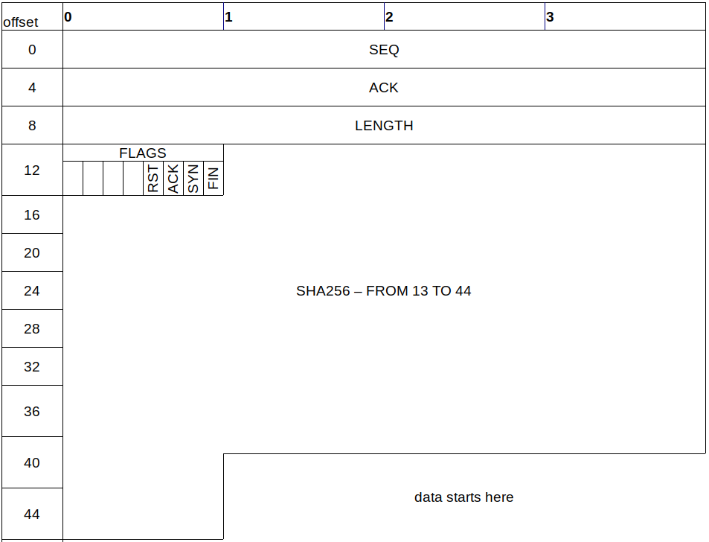
As for issues that we aren’t too sure about at the moment, there is not too much. One complicated issue would be optimizing the number of server windows, however we don’t think it will be that big of an issue.

Furthermore, we have not discussed how the proxy will be made yet, so that is one of the major issues we need to deal with as well.

